

**Extreme Identification Of Navigation**

**What is Road Sign Detection?**

* Road Sign Detection is a computer vision task that involves the automatic identification and localization of road signs in digital images or video streams. It is a subtask of object detection, which aims to detect and classify specific objects of interest within an image.
* When it comes to detecting and mitigating threats, speed is crucial. So as our prototype is highly time efficient approximately 5000 milliseconds.

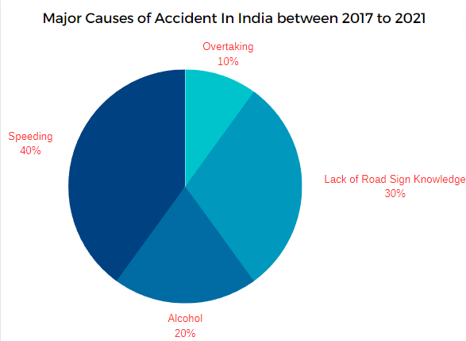

**Datasheet**

The German Traffic Sign Benchmark is a multi-class, single-image classification challenge held at the International Joint Conference on Neural Networks (IJCNN) 2011. We cordially invite researchers from relevant fields to participate: The competition is designed to allow for participation without special domain knowledge. Our benchmark has the following properties:

* Single-image, multi-class classification problem
* More than 40 classes
* More than 50,000 images in total
* Large, lifelike database

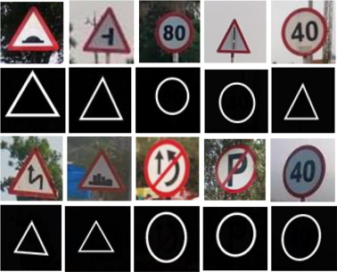

**A Snapshot of Datasheet**

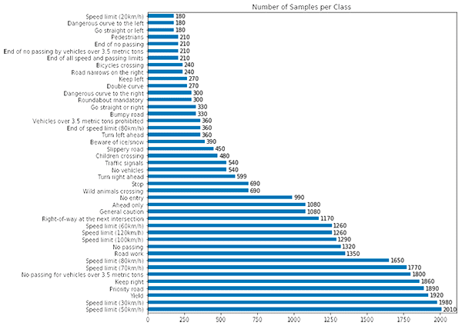**Collection of data in German Traffic Sign Benchmark**

**Model Selection**

In traditional machine learning models, we cannot store a model’s previous stages. However, SSDlite_mobilenet_v2 can do this for us. Let’s take a closer

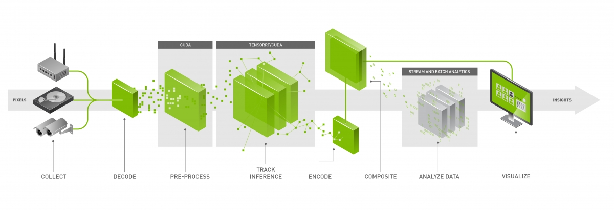

A ssdlite_mobilenet_v2 has a repeating module that takes input from the previous stage and gives its output as input to the next stage. However, in ssdlites_mobilenet_v2, we can only retain information from the most recent stage. To learn long-term dependencies, our network needs memorization power. Here’s where International Joint Conference on Neural Networks (IJCNN) come to the rescue.

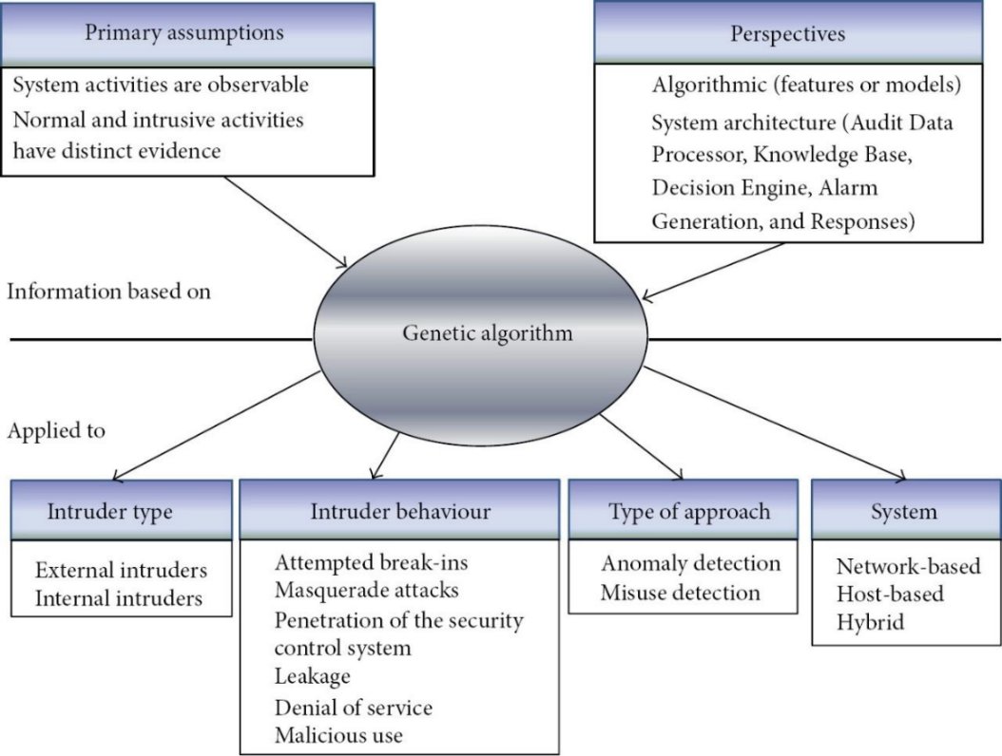

**Implementation**

Embedding -: Text data can be easily interpreted by humans. But for machines, reading and analyzing is a very complex task. To accomplish this task, we need to convert our text into a machine-understandable format.

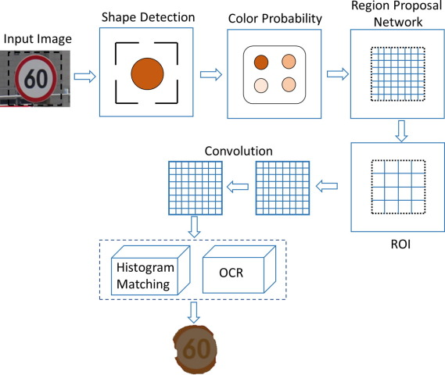Embedding is the process of converting formatted text data into numerical values/vectors which a machine can interpret.

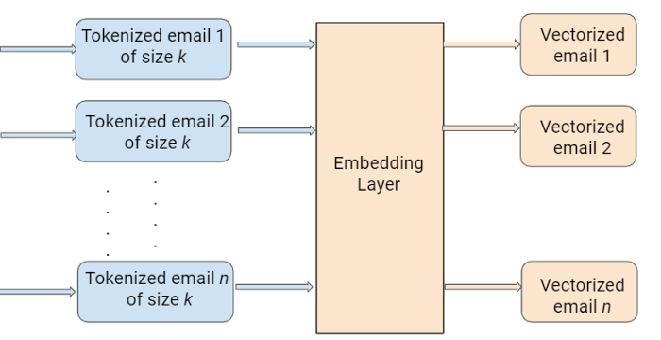

Process flow in text preprocessing along with expected output

**Summary**

The following diagram summarizes the steps involved in training the Road sign detection model and its integration in a live environment.

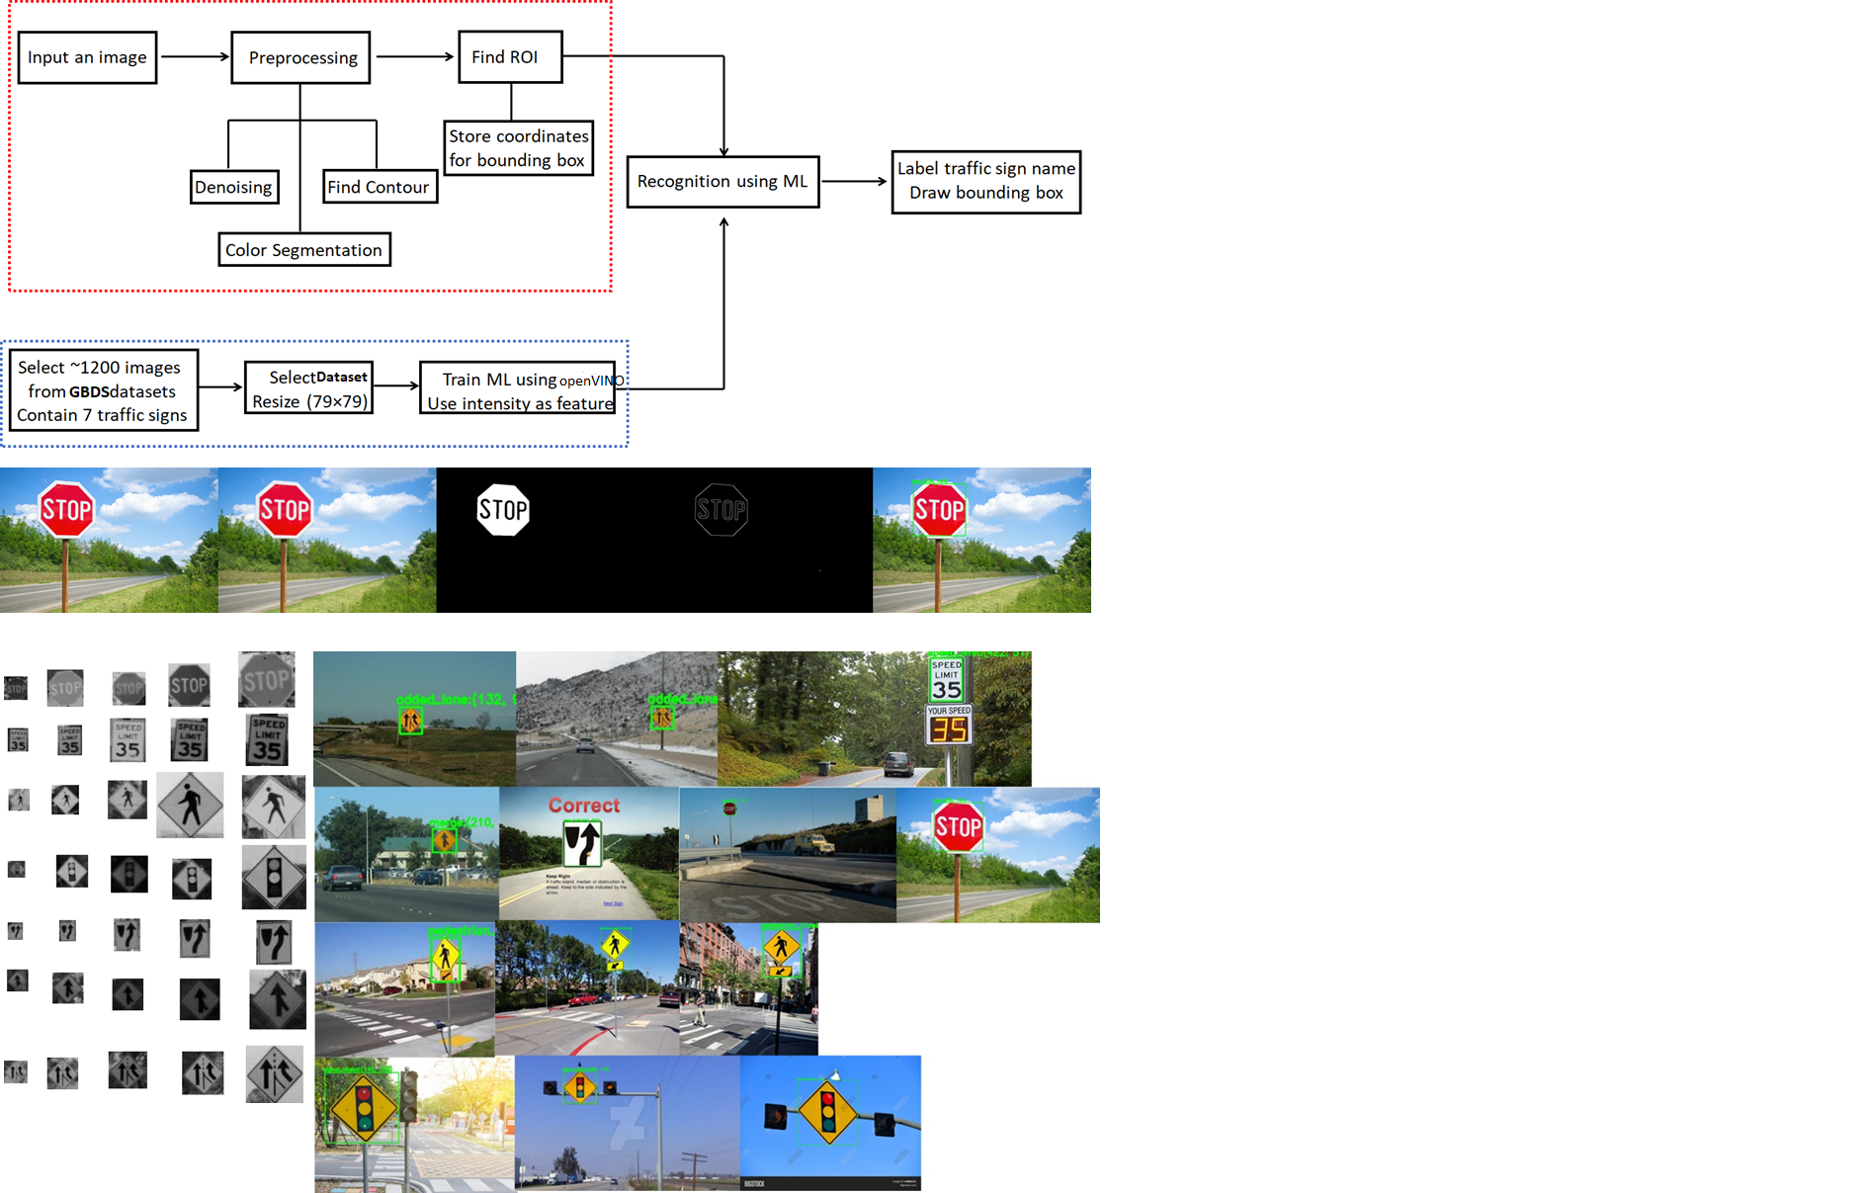

* Automatic labelling based on frequency allows for a reasonable creation of a labelled dataset.
* Road Sign detection can be re-framed as a regression problem and the added structure of message spam probability provides a more subtle classification.
* The model successfully detects road sign patterns seen on the training set.
* Results improve considerably from better labels.
* Road Sign probabilities should not be interpreted in a vacuum but rather in the context of the problem and the analysed dataset.
* Running the model on the cloud is very cheap due to its speed and low memory usage.

REFERENCES

[1]. German Traffic Sign Recognition Benchmark https://www.kaggle.com/meowmeowmeowmeo wmeow/gtsrb-german-traffic-sign

[2]. Intelligent Transportation Systems ITS https://en.wikipedia.org/wiki/Intelligent_ transportation_system

[3]. Advanced Driver Assistance System ADAS https://en.wikipedia.org/wiki/Advanced_ driverassistance_systems

[4]. RGB HSI https://www.vocal.com/video/rgb-andhsvhsihsl-color-space-conversion/

[5]. J. Stallkamp, M. Schlipsing, J. Salmen, and C. Igel, “The German traffic sign recognition benchmark: a multi-class classification competition,”. in Proc. IEEE IJCNN, 2011, pp. 1453–1460.

[6]. Valentyn Sichkar, Sergey A. Kolyubin, “Effect of various dimension convolutional layer filters on traffic sign classification accuracy”.

[7]. Yi Yang, Hengliang Luo, Huarong Xu and Fuchao Wu, Towards Real-Time Traffic Sign Detection and Classification 2014, IEEE.

[8]. Kai Li, Weiyao Lan, “Traffic indication symbols recognition with shape context”. Department of Automation Xiamen University, China, 2011, IEEE

[9]. DarkNet Framework https://pjreddie.com/darknet

**Future implementation**

—Improve labels. This is by far the most important thing. The quality of the data is very highly correlated with the quality of the predictions. Some of the possibilities are:

— Use message clustering after feature extraction to group similar messages together and manually label a representative of the group. The label is then shared with all data points in the group.

— Come up with better labelling heuristics.

— Use road sign data from other sources (with care) if it helps training.

— More research can be done to make an AI that can verify reports , images and videos automatically without human intervention and make the entire process smooth and fast.

— More manual labelling.